2002 International Convocation Webpage Launched
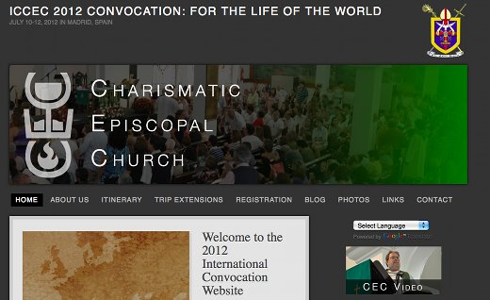
The web page for the ICCEC International Convocation, being held July 10th-12th, 2012 in Madrid, Spain has been launched.
WWW.CECMADRID.COM
The web page contains all of the information required to plan your trip to Spain for the convocation, including an itinerary, pricing, registration and options for extending your trip for a holiday either before or after the convocation.
We encourage you to register for the convocation as soon as possible and we look forward to seeing you all in Spain!

