Letter to the Clergy regarding the Feast of Our Lord the Giver of Life, from Patriarch Craig Bates
On January 15th, 2012, the Charismatic Episcopal Church celebrates the Feast of our Lord the Giver of Life. (Church of the Messiah will celebrate this on January 22nd)
John 10.10 reads, “The thief does not come except to steal, and to kill, and to destroy. I have come that they may have life, and that they may have it abundantly.” On this coming Feast Day, the Church proclaims that it is in relationship with the Risen Christ so that men and women may find true life. Because Jesus not only gives abundant life, He alone is life. (John 14.6)
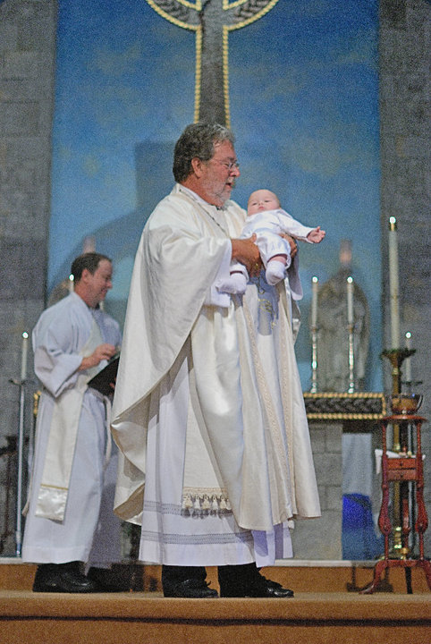
John 10.10 also reminds us that the Church is in a spiritual war. This scripture tells us, particularly those of us in the North American Church, that the battle line is drawn between a post-modern, hedonistic, consumer driven, materialistic, contraceptive culture of death and the liberating, restoring, reconciling, eternal Gospel culture of life. This is an ancient spiritual battle that has crossed time and space, and it will be waged until our Lord - the giver of life - finally comes again to fully establish His Kingdom.
As you read this letter, thousands of babies will be murdered in the womb of their mothers. Thousands of women and men will remember today as the day they aborted their child, and they will be scarred for life–physically, emotionally, and spiritually.
Why are these children murdered? Because the enemy is waging a battle, and he has argued very effectively that poverty is a result of giving birth to children. There is just too much life. If we had fewer children, the argument goes, then we would have less poverty, less disease, and less hunger. Abortion is aimed not at the rich, who have all the resources, but at the poor.
This is just as true in the the United States as it is anywhere else. The African American community, for example, is disproportionately targeted by the abortion industry. Since 1973, over 25% of the black population has been exterminated by abortion. Today, almost as many African American babies are aborted as are born, making it three times more likely for a black baby to be killed in the womb than a white baby. In fact, In the last 30 years, more than twice as many African Americans have died from abortion as from AIDS, accidents, violent crimes, cancer and heart disease combined.
The abortion industry seeks to convince women and men, especially those who are impoverished, that their life would be better and easier without children. That is why Planned Parenthood operates the largest chain of abortion clinics in the United States with 80% of them placed in minority communities. And African American women, though they only make up 13% of the American population, have 35% of all abortions, earning the US abortion industry more than $16,000 an hour for the killing of African American babies.
Abortion is also an attack on our youth. This generation, more than any other in my lifetime, is surrounded by and indoctrinated in a secular, postmodern humanism. In New York City, the government is hiring a “condom coordinator.” This person will be paid over $80,000 a year plus benefits to ensure that condoms are made available to students in Junior and Senior High School.
The new sex education program that is offered and required of students between ages 11 and 18 includes such topics as oral sex, homosexuality, anal sex–even instructions on how to have oral sex if you have braces. At the same time, God or even a religious view of the world is forbidden to be talked about in public school. Curriculums are increasing more and more morally relative and based in a totally utilitarian understanding of truth and life. More than ever, we, as the Church, must raise up a generation that can win the culture for Christ.
CEC For Life is a large part of that. While I am the Patriarch of the worldwide communion of the Charismatic Episcopal Church, I am also the Senior Pastor of a local parish church. In my congregation there are young men and women who, by the grace of God (and often at their parents leading), are in the pews every Sunday.
Many of them face public school each day, and CEC for Life has been more than helpful in putting a fire in them for Jesus. Year after year, we have brought these young people to the March for Life, sent them to Ireland, and rallied them at Planned Parenthood for the Liturgy for the Preborn. Now many of them have committed themselves to living holy, chaste lives so that they can become leaders in the Church and be a Joshua generation that will conquer the land and see an end to abortion in America.
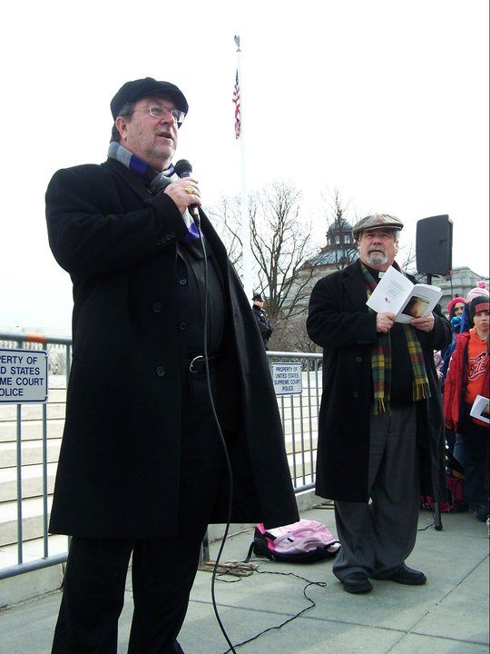
When I became the Patriarch of the Church, my first official act after my enthronement was to go to Washington, D.C. and join the American youth of our communion at the March for Life. My second act as Patriarch was to make CEC for Life more than just a ministry of the CEC, it is now an arm of the office of the Patriarch. Then, last year, Fr. Terry stepped out of the full-time pastorate as an act of faith to work full-time for CEC for Life and for me. The Bishops of the American Church confirmed this call and pledged their support.
When we take up the annual offering, I believe we are being obedient to the word of the Lord given to our Bishops. And I believe obedience opens the door to more blessings.
We are also making a powerful spiritual statement in the heavenly realms. We are letting the principalities, powers, and forces of wickedness know that we are standing in prayer–spiritual warfare–not only for ourselves but also for generations of little ones. We are bringing about a generation of warriors for the Gospel.
On a personal note, as I write this letter in my office at home, my 4-yr-old grandson is running up and down the hallway pretty much ignoring the voice of his mother, who is trying to get him ready to go out. I can hear the patter of his feet and the laughter as he taunts his mother, who is not well pleased or happy. Yet, the patter of those feet and the laughter are a sign of life. He is a survivor of the holocaust of abortion. And he has brought more joy into my heart than any object or possession could ever begin to bring to me. He is the fulfillment of John 10.10.
On Sunday, January 15th, 2012 please join me in celebrating the Feast of Our Lord the Giver of Life. Please prepare a pro-life sermon for that morning’s service and take up the offering for CEC for Life. In addition, please also include your CEC For Life church membership and clergy dues. Then send in the offering, membership, and dues all at one time.
Together, we will all take part in this holy task of life and continuously pray that there is a day when we will see and know that all Life is sacred.
Under His mercy,
The Most Rev. Craig W. Bates,
Patriarch, ICCEC

