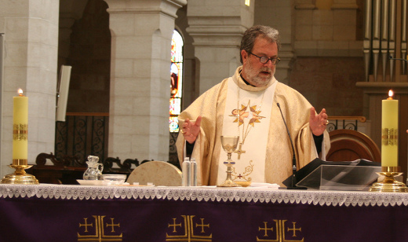
MALVERNE, NY - The liturgies of Holy Week and the Feast of the Resurrection of our Lord Jesus Christ are the cornerstone of our faith. Because of the significance and depth of these holy events, I find that preparation for an Easter message is one of the hardest tasks I face each year. This year my reflections have centered on the message of hope.
It seems so often that the culture of death is expanding its reach. What was un-thinkable among civilized people – abortion, euthanasia, and infanticide – is now openly debated in the halls of government. No longer is “murder” of the weakest among us considered evil. Rather we are told that “abortion” is an acceptable form of women’s health care, euthanasia is compassionate, and infanticide saves the newborn from a life lacking in quality. The proponents of the culture of death are spending billions of dollars to spread their demonic message to Asia, South America, and Africa all in the name of “reproductive and women’s health care”.
In the Northern Hemisphere, particularly Western Europe and North America, people are living in a moral confusion caused by the acceptance of moral relativism, secular humanism, materialism, and hedonism.
Throughout history there have been long seasons of darkness. This past year I was blessed to be able to read “Bonhoeffer: Pastor, Martyr, Prophet, Spy” written by Eric Metaxas. Bonheoffer was a Lutheran Pastor and Academic during the rise of the Third Reich. He was executed in a concentration camp just weeks before the fall of the Reich. The book is a compelling story of a man who had to live in the darkness of one of the most evil regimes of the 20th century. It tells a story of a man whose deep faith in Christ led him to be a bold spokesman for righteousness and holiness in the midst of the darkness. This faith led him to martyrdom. If you have not read this powerful testimony I encourage you to do so.
Those who have chosen to follow Christ, throughout the ages, have been called to a participation in the death and resurrection of Jesus. We are we are called to give our lives for the sake of others, particularly the least, the lost, and the lonely.
Our faith informs us that it is never too dark and that darkness will not prevail. By all accounts the crucifixion of Jesus was meant to be the end of a movement. The horrific act of crucifixion was meant not only to execute the leaders of a movement but also to instill fear in the followers. I am sure the leaders of the Temple, the Pharisees, the Sadducees, and the Roman authorities all were convinced that with the death of Jesus by crucifixion it would be the last they would hear from the followers of Jesus.
The Scripture records that indeed our Lord’s crucifixion did instill fear in the disciples. From the moment Jesus was sentenced to death we find the disciples (with the exception of John) hiding in fear. Jesus finds his followers huddled and hiding in fear - in fear that they too would soon be arrested and face the same fate as their Master. It is here that Christ comes to meet them.
With the offer of peace and the receiving of the Holy Spirit, a transformation begins to take place in the followers of Christ so that by the Feast of Pentecost and the outpouring of the Holy Spirit the timid and fearful disciples are so radically transformed that what they feared the most – martyrdom – they now embraced with the hope of eternal life. Death no longer had any power over them.
The hope of Easter is that death is never the end of the story. The crucifixion is not the final word, nor is martyrdom the final word. At the heart of the Christian Gospel is the message that death is conquered and at the grave we can make our song, “Alleluia.” As the preface of the Mass of the Resurrection states, “for those who believe life is not ended but changed.”
The hope of the resurrection compels us to look beyond the circumstances of life and lift up our eyes to the King of heaven. The Church will prevail against the culture of death. The Church will continue to find its life among the poor, the deprived, the homeless, the hungry, the addicted, and the least among us – the preborn.
We have been given the gift of life – abundant life. The resurrection calls us to become evangelists of this good news of life - even in the darkness. Our faith in Christ makes us messengers of hope. It is a hope that will not disappoint us because the Holy Spirit God has given us has poured the love of God into our hearts. It is the message that Christ Jesus transformed the lives of disciples from fear to faith, hope and love. Today those who come to know Jesus will partake of the same transformation.
I know each of you will celebrate a glorious Easter Day. It is appropriate that we mark the resurrection with a feast. Be it is more important that day-by-day we live the resurrection in the midst of darkness. My prayers are with you during this most holy time of the year. May the liturgies of Holy Week and Easter renew you and empower you.
Under His mercy,
+Craig, Patriarch

